Risk Profiler

View By:

Earthquake Scenarios Probabilistic Risks Training Download About Contact

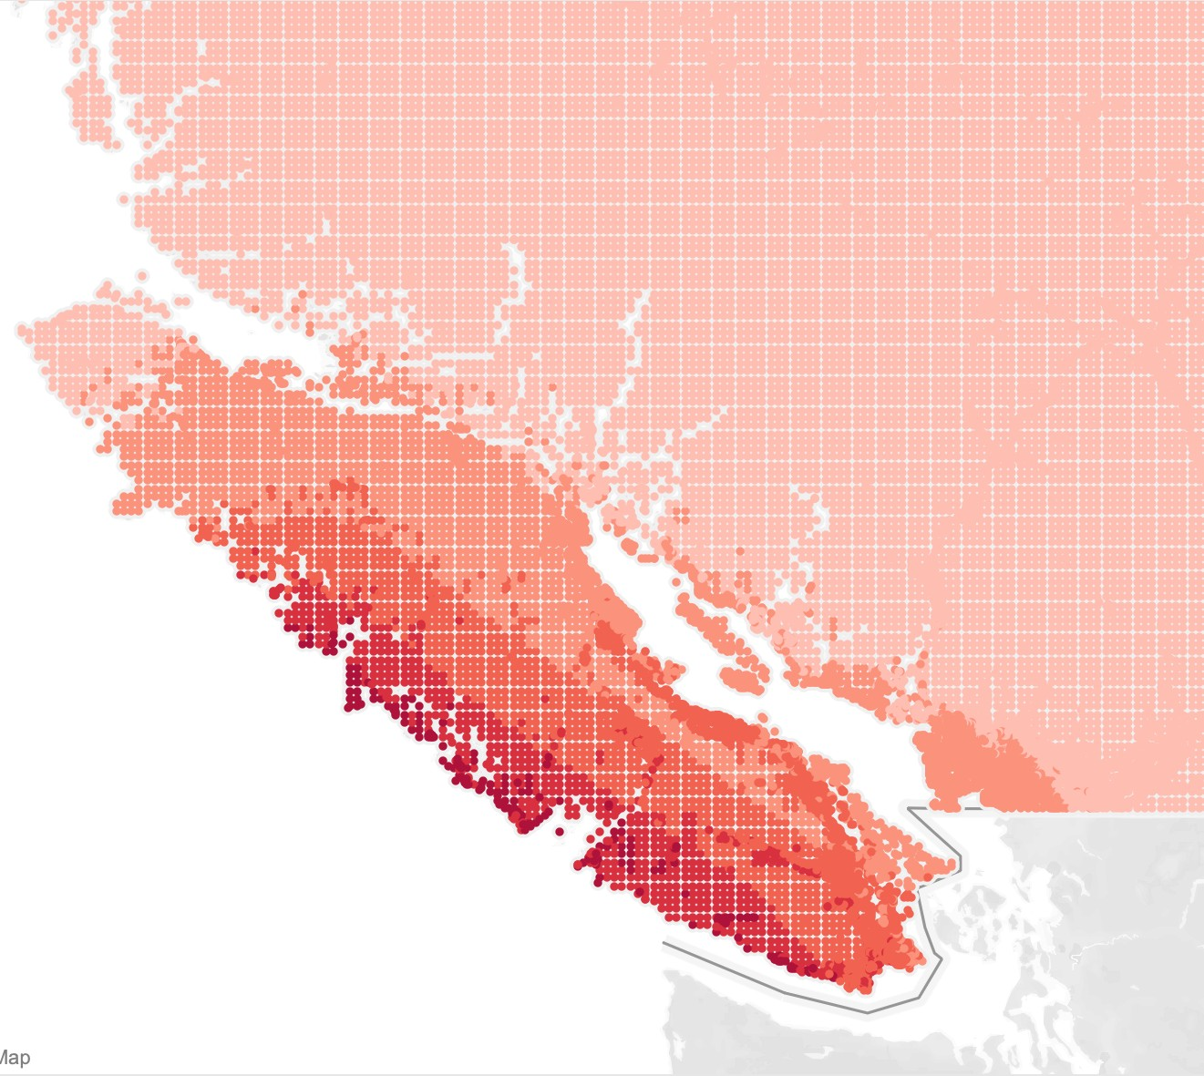

or View List

**+**

**-**

Go

Search By Local Authority

Back to:

Scenario Catalogue

New? Take The Tour



Footer

**Scenario Name: Mw 9.0 Cascadia Interface**

This is a moment magnitude 9.0 earthquake on the Cascadia Subduction Zone. Earthquakes like this occur about once every 400-500 years, with the most recent event in January 1700.

**Deaths: 23423 for Scenario Damage: 23412 for Scenario Dollars: $23232 for Scenario**

Select indicator:

Shake Map

To view graphs, select an indicator